Klasa 4, cz.2

Zadania proszę rozwiązać i przesłać mi na e-maila (mogą być zdjęcia)

Zadanie1

Czasy teraźniejsze

1 Wybierz prawidłową formę czasownika.
0 This semester we are studying / study the Second World War.
- My mother is a doctor. And what is your father doing / does your father do?
- My two best friends are lawyers. But they’re not working
/ don’t work at the moment.
- Most banks in my area are closing / close at 5.30 p.m.
- Bad news. The price of petrol’s going up / goes up
again.
- Do you speak / Are you speaking any other foreign languages?
- Hurry up! We‘re running / run late!

/6

2 Wykorzystując podane w nawiasach wyrażenia, utwórz zdania oznajmujące (+), przeczące (–) lub pytania (?)
w czasie Present Simple lub Present Continuous.
0 I don’t like broccoli. (?) (Tom, spinach)

Does Tom like spinach?
- I am learning Japanese. (?) (you, Chinese)

- Where do you come from? (+) (my father, Germany)

- Are you talking on the phone? (+) (she, on Skype)

- We go to the cinema every week. (?) (he, often)

- Ella gets up early on Saturdays. (–) (Bethany and Alexia, on Sundays)
/5
3 Przetłumacz podane fragmenty zdań na język angielski, używając czasowników w odpowiedniej formie czasu Present Simple lub Present Continuous.
0 My little sister asks (zadaje) me questions all the time.
- John, what (myślisz) about? Listen to me!
- I’m afraid Robert (nie pamięta) my telephone number.
- Why (potrzebujesz) so much money?
- Slow down! You (jedziesz) too fast!
- I (nie wiem) much about Ancient Rome.
- Why (ona się śmieje)? What’s so funny?
- Oh, no! It (pada deszcz) again!

/7

4 Wstaw czasowniki w nawiasach w odpowiedniej formie czasu Present Simple lub Present Continuous.
My driving course 0 is going (go) well and, to my surprise, I 1 (enjoy) it very much. Harry and Liz, who run the driving school
in my area, 2 (seem) very professional. But what I like most about them is that they 3 (feel) like friends rather than teachers. I know I’m making a lot of stupid mistakes (still!) but they keep saying: ‘Don’t worry.
You 4 (learn). Everybody
5 (need) to go through this stage’. They always 6 (concentrate) on the positive and 7 (support)
me in every way. It’s great that Anna from my school
8 (do) the course with me. At the moment we 9 (practise) different driving manoeuvres. Anna 10 (find) them really difficult but she 11 (get) better and better. I 12 (think) we will both pass our driving test in March.
____ / 12
zadanie 2

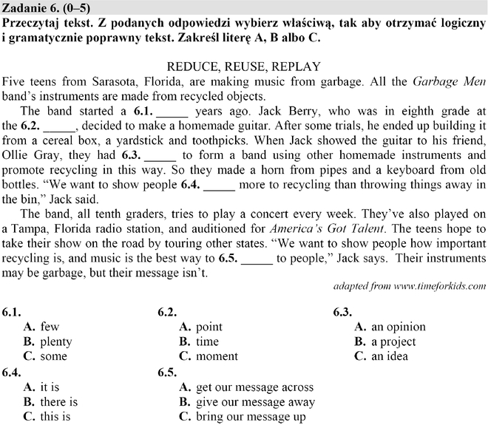

zadanie 3

Człowiek

1 Uzupełnij każdą lukę w tekście tylko jednym wyrazem.

I’m really 0 fed up with some of the people in my class. They can be so immature. They 1 m fun of people who try to be different from them and they
2 l down on anyone who doesn’t have the ‘right’ taste in music. Last month, a new student joined our class. She’s very nice but quite shy. I was the only one who talked to her. I’m glad I did because, when I got to
3 k her, I found out that we had a lot in
4 c . One thing is that we both think that some of the other people in our class should
5 g up and start acting their age.

2 Uzupełnij wyrazy. Każda kreska odpowiada jednej literze.

Hi Kate,
Help! I’m really 0 s t r e s s e d out at the moment because of my date with Harry. I’m really ¹ _ _ _ v _ u _
about it. I’m really ² _ t _ _ _ c _ _ _ to him and I want it to go well but I don’t know what to wear. Can you come round and help me?
Lisa

Hi Lisa,
Don’t worry. It doesn’t matter what you wear. You’ll still look ³ _ o _ g _ _ u _! Remember, your eyes are
your best feature. Put on a bit of ⁴ _ _ s _ _ _ a – not too much. Oh, and wear ⁵ _ _ a _ shoes. Harry doesn’t like high-heels. I’ll see you in a few minutes. Don’t panic. Kate
zadanie 4:
Arkusz maturalny 1:

https://www.terazmatura.pl/plik/pobierz/58/567-a-pp-a-xii-2013

https://www.terazmatura.pl/plik/pobierz/58/588-a-pp-q-xii-2013

https://www.terazmatura.pl/plik/pobierz/58/600-a-pp-t-xii-2013

